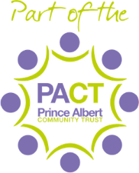

Letter to Class 4H Parents:
Tuesday 15th September 2020
Dear Parents and Carers,
Firstly, can I thank a large number of you for the positive feedback and support that many of you have offered us since we returned to school. This is very much appreciated and makes a huge difference to us all.
Following on from the text messages that you received today, I have spent much of the evening working with Public Health England to ensure that we are taking the right actions to keep our school family in good health. They have advised that ALL children and affected staff in Class 4H need to self-isolate for 14 days from today. This means we look forward to welcoming your children back on Wednesday 30th September. The advice from Public Health England is that children will only need to be tested if they develop any of the symptoms as listed on the DfE and NHS websites:
· a high temperature – this means you feel hot to touch on your chest or back (you do not need to measure your temperature)
· a new, continuous cough – this means coughing a lot for more than an hour, or 3 or more coughing episodes in 24 hours (if you usually have a cough, it may be worse than usual)
· a loss or change to your sense of smell or taste – this means you've noticed you cannot smell or taste anything, or things smell or taste different to normal
If your child is entitled to a free school meal, we are able to provide a packed lunch for them throughout the period of their self-isolation. You will be able to collect them from outside the main office at midday each day.
Staff and leaders across school are working tirelessly to ensure that we are following all of the guidance being issued. I appreciate that this is a very worrying and challenging time for the whole Sutton Park Primary family and thank you for your support.
Best wishes,

Mrs Middleton
Head of School

