Christmas at Sutton Park Primary School Friday 25th November 2022

Dear Parents and Carers,
Christmas is an important and exciting time for many of our school community. This year sees the return of several Christmas traditions at our school. These are summarised in this letter to support family members in being part of those things they can attend. We hope to see lots of our families joining us for these events and thank you in advance for your support with fundraising events.

Christmas Tree Light Switch-On:
On Monday 28th November, we welcome you to join us at the foot of our school Christmas tree (adjacent to Lewis playground) for carols and our light switch-on. We will gather for this tradition from 3:25pm so please join us after collecting your children if you can.

Christmas Cards:
With no Covid restrictions, our festive school post-box is returning! Pupils can write and post cards for their friends across school. The Y6 prefects are fulfilling duties on our ‘Postal Elf’ rota and will ensure the cards are delivered to classes across each school week. Please support them by ensuring the recipients class/year group is included on the front of the envelope. Thank you!

Christmas Dinner:
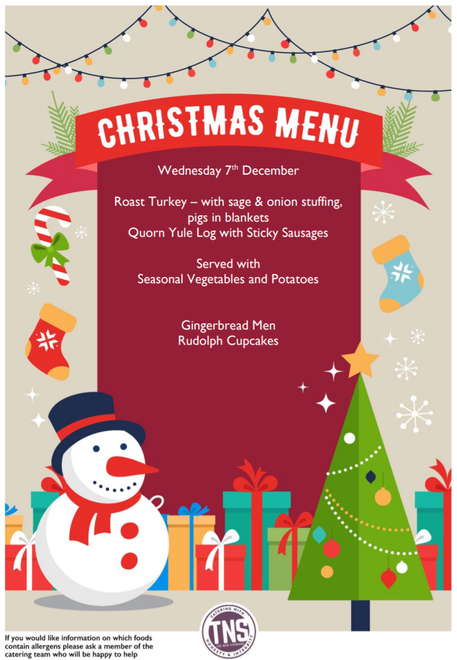
Our amazing catering team are planning another delicious feast for our pupils and staff. This year’s lunch will take place on Wednesday 7th December and is open to any child in school. If your child is already booked for a lunch on this day, or usually has a Universal/Free School meal each day, they will automatically be booked for this special festive treat. If your child is usually sandwiches but would like to book for a hot school dinner on this day, please book and pay for their lunch on the ParentPay platform by the end of the school day on Wednesday 30th November. Our chef needs accurate numbers by this date so that they can order ingredients and plan ahead. Any orders after this date cannot be fulfilled.

Santa’s Grotto:
In previous years we have hosted the main man of Christmas in a special grotto in school to raise funds for resources. Parents have previously paid and prebooked their child’s place. This year - with a heightening awareness of the impact of the cost-of-living crisis on our community - we are not charging for this opportunity. The most important thing for us is that all 330 of our pupils will get to see Santa and receive a small gift from school this festive season.

Christmas Fayre Donation Day:
To support our fundraising fayre efforts, Friday 2nd December is a non-uniform, donation day. Pupils are invited to wear festive clothing (Christmas jumpers, red/green clothing etc.) in return for a donated item:
- EYFS to Y2 – chocolate for the chocolate tombola
- Y3 to Y6 – a bottle for the bottle tombola (drinks or beauty items)
These donations/stalls are a key part of our fayre so we thank you in advance for your support with this.
Christmas Fayre:
Our Christmas Fayre is taking place on Friday 9th December from 3:30-5pm. This will be a super, community event and will include the traditional stalls, refreshments and local craft stalls. We will also be announcing winners of our ‘design a Christmas stocking’ competition. This is free for all pupils to enter and entries will be on display on our gallery wall during the event. Entrance to the fayre costs 50p per person but includes a raffle ticket for our annual hamper raffle. (This will also be drawn during the fayre.)

Christmas Performances:
In line with our calendar dates previously shared, pupils in all year groups will be involved in a Christmas performance or Carol Concert this December. This is a lovely opportunity for family members to come into school and see their loved one perform/sing their little heart out. Remember to pack your tissues!

Tuesday 13th December | EYFS Nativity  Y1 Nativity | EYFS – 9:15am  Y1 – 10:15am  (INFANT HALL, PLEASE ENTER SCHOOL VIA THE MAIN ENTRANCE)
Wednesday 14th December | EYFS Nativity  Y1 Nativity | EYFS – 1pm  Y1 – 2:15pm  (INFANT HALL, PLEASE ENTER SCHOOL VIA THE MAIN ENTRANCE)
Thursday 15th December | Y2-4 Carol concert  Y5-6 Carol concert | Y2-4 – 9:15am  Y5-6 – 10:15am  (JUNIOR HALL, PLEASE ENTER SCHOOL VIA THE MAIN ENTRANCE)

Christmas Party Morning:
The last day of term is Friday 16th December and school closes at 1pm to all pupils on this day. (There is no Friday Club provision.) This is a non-uniform day with pupils invited to wear party clothes. They can also bring in snacks to enjoy during the party. Please provide snacks for your child only, in a named sandwich bag. As always, no nut products are permitted, and snacks will not be shared with other children due to possible allergies.

Thank you for your continued support. On behalf of the Sutton Park Primary team, we wish you a joyful December and hope your children enjoy the Christmas countdown in school.

Mrs Middleton
Head of School

