Sutton Park Primary School Remote Learning Plan

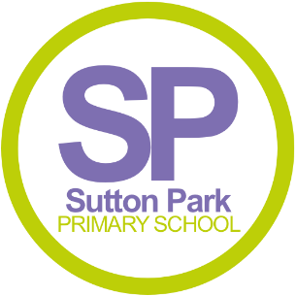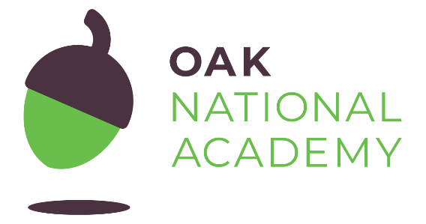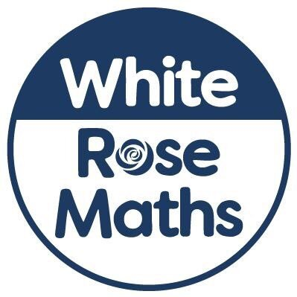
The current situation in schools is challenging and we appreciate all parental support in engaging with the Covid-19 testing where needed. Under the DFE guidance, it is clear that children have a right to their education – in school or at home. We will not provide work for symptomatic children who are unwell and off school as a result. The focus here is on getting better as would always be the case with absence related to illness. However, there are other circumstances which could arise where work needs to be set by school.
In order to ensure that learning is continued, irrespective of lockdown and self-isolation, Sutton Park Primary School has developed the following plan. This plan offers remote learning opportunities whilst also acknowledging that some households have limited access to devices and would require hard-copies of work and resources.
This plan will be applied in the following instances:
- An individual is self-isolating because of a positive test within the household;
- A group of children are self-isolating because of a case of coronavirus in the bubble;
- A whole bubble or cohort is self-isolating because of an outbreak of coronavirus.
The plan complies with the expectations and principles outlined in the DFE document Guidance for Full Opening of Schools.
Software and online platforms
Within all plans, teachers will set appropriate work in-line with our current curriculum, primarily supplemented by a range of resources provided by Oak Academy and White Rose Maths.
Children will remain in contact with their class teacher through MS Teams and their allocated class email address.
Oak Academy has been selected to support remote learning for a number of reasons. The Oak Academy lessons are in-line with our teaching ethos – they encourage the use of retrieval practice, explicit teaching with high quality modelling, and the use of deliberate practice. The online lessons are free to all and offer a recorded taught session so that the children can access physical teaching from a teacher and then access work relating to that lesson within the same website. There are also hundreds of lessons specifically aimed at children with SEND needs and requiring additional support.
White Rose Maths resources will be used as they are matched to our current maths curriculum model. Children are very used to seeing these resources. We use the White Rose Maths approach in school for our daily Maths lessons so this will allow for seamless continuation of the learning they would be doing in school.
Oxford Reading Buddy, Spelling Shed, Numbots, and TT Rockstars will all be utilised to support the acquisition and retention of basic core skills. These online subscriptions are accessible to all pupils in Years 1-6 – every child has a personalised log in for these resources and copies of these will be sent home for those who may have misplaced them over the summer.
MS Teams will support school in offering online learning with the opportunity for the children to communicate with their teacher through the class chat function and also via video sessions as the remote learning offer grows over time. MS Teams will enable class teachers to continue reading aloud to pupils e.g. sharing their current class text for Literacy or a class assembly.

We have also set up a class email address for every class. This allows for easy communication between parents and teachers as we know that the current lack of face-to-face contact each day at drop off and collection is not our usual approach and difficult for some parents to adjust to. Throughout school closure, the schoolclosure@ email was used successfully to communicate with parents and answer any queries or questions. Now that school has returned fully, this email address is no longer in use and for day-to-day class queries, you can instead contact class teachers/phase leaders directly.
In the event of any form of isolation and loss of learning caused by Coronavirus, parents must understand that engagement in home learning is compulsory, as is the expectation that Sutton Park Primary School makes that provision available and accessible to all. However, if children themselves are too ill to attend then they should not be expected to engage in home learning.
In preparation for home-learning, parents and children will receive logins and passwords for the following platforms:
- MS Teams
- Spelling Shed
- TT Rockstars/Numbots
- Oxford Reading Buddy

Worksheets and Practical Resources
We have prepared paper packs for all year groups to ensure that home learning is immediately available for those individuals needing to isolate. If a child is isolated from school i.e. the child is sent home from school to either receive a test or self-isolate as someone in the household is being tested, we will endeavour for them to leave school with a pack of work. This ensures that children have immediate access to home learning, continuing their learning despite the need to isolate.
The work packs should be basic skills work that would be relevant at any stage of the year e.g. arithmetic, spelling, reading, writing (with a visual prompt) and handwriting. If required, stationery can also be provided by school to ensure there are no barriers to beginning this work.

Remote Learning
The initial response to any isolation will be to provide children with home learning materials alongside their class stationery pack (this might need to be delivered). In the case of whole cohort isolation, resources will be uploaded to MS teams.
Pupil needs to isolate because someone in their household is symptomatic or tests positive
School role: | Parental role:
Paper based home learning packs will be provided by school. These can be returned in one of two ways: in paper form at the end of the isolation period or electronically via the class email address.  If assistance or support is needed, an email to the class email address allows for direct contact with your child’s class teacher/ phase leader. They will reply as quickly as they possibly can within the hours of their school working day (8am-4pm) | Support your child in engaging with the learning provided by school.  Parents to ensure a test has been taken and to make sure that test results are communicated quickly to enquiry@suttonparkprimary.co.uk  If child is entitled to free-school meals, packed lunches can be provided by the school kitchen. These will be available for contact-free collection from the front of school at 12 midday.
A group of children are self-isolating because of a case of coronavirus potentially affecting their class bubble
School role: | Parental role:
Paper based home learning packs will be provided by school to allow home learning to begin instantly and to support those who may have limited access to devices/wifi. These can be returned in one of two ways: in paper form at the end of the isolation period or electronically via the class email address.  The children will receive work via MS teams from their class teacher. This will be set via the ‘posts’ function on their class channel. Any messages written on the posts function are visible to all class members (for any further information/support with MS Teams please see your parent handout)  This work may include links to Oak National Academy, White Rose Maths or other online learning resources. Expectations for the tasks which children need to be complete will be shared by the relevant class teacher. Work completed can be submitted via MS teams (visible to all class members) or separately via the class email address.  Children working from home will also be able to access whole-school assemblies which are currently being recorded due to Covid-19 restrictions. These will also be shared via MS Teams. | Support your child in engaging with the learning provided by school.  If requested by school, or if your child develops symptoms during their period of self-isolation, please take your child for a test and communicate the results quickly to enquiry@suttonparkprimary.co.uk  If child is entitled to free-school meals, packed lunches can be provided by the school kitchen. These will be available for contact-free collection from the front of school at 12 midday.

Class emails
EYFSMissP@suttonparkprimary.co.uk | Miss Painting (The Gruffalos)
EYFSMrsJ@suttonparkprimary.co.uk | Mrs Jones (The Zogs)
class1D@suttonparkprimary.co.uk | Mr Day (Y1)
class1CS@suttonparkprimary.co.uk | Mrs Stanley & Miss Connolly (Y1)
class2N@suttonparkprimary.co.uk | Mrs Newbold (Y2)
class2DN@suttonparkprimary.co.uk | Miss Nock (Y2)
class3T@suttonparkprimary.co.uk | Miss Trowman (Y3)
class3AB@suttonparkprimary.co.uk | Mrs Msanide-Brookes & Mrs Akhtar (Y3)
class4H@suttonparkprimary.co.uk | Mr Hill (Y4)
class4K@suttonparkprimary.co.uk | Miss Kyle (Y4)
class5D@suttonparkprimary.co.uk | Miss Dhillon (Y5)
class5A@suttonparkprimary.co.uk | Miss Archer (Y5)
class6A@suttonparkprimary.co.uk | Mr Allen (Y6)
class6G@suttonparkprimary.co.uk | Miss Gorringe (Y6)
nurture@suttonparkprimary.co.uk | Mrs Runacus (Nurture Gp)

