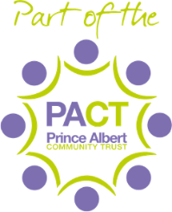

Letter to all parents of unaffected classes:
Tuesday 15th September 2020

Dear Parents and Carers,
Firstly, can I thank you all for the ongoing support that you have provided throughout this difficult period so far. This is very much appreciated and makes a huge difference to us all.
As some of you may be aware, unfortunately, we have had notification of a positive COVID-19 test within school. I have liaised with Public Health England to ensure that we are taking the right actions to keep our school community in good health. The advice that Public Health have given is outlined below:
Only staff and children within the specific classes affected need to self-isolate.
Siblings of children in Classes 3AMB and 4H are advised to continue to attend school.
Children in other year groups are advised to remain in school.
As per the guidance from Public Health England, children will only need to be tested if they develop any of the symptoms as listed on the DfE and NHS websites:

•a high temperature – this means you feel hot to touch on your chest or back (you do not need to measure your temperature)
•a new, continuous cough – this means coughing a lot for more than an hour, or 3 or more coughing episodes in 24 hours (if you usually have a cough, it may be worse than usual)
•a loss or change to your sense of smell or taste – this means you've noticed you cannot smell or taste anything, or things smell or taste different to normal
We will continue with our thorough cleaning schedule that we have in place and will ensure that a further deep clean of school takes place this evening.
Staff and leaders across school are working tirelessly to ensure that we are following all of the guidance being issued. I appreciate that this is a very worrying and challenging time for the whole Sutton Park Primary family and thank you for your support.
Best wishes,

Mrs Middleton
Head of School

